Word Document Template for CIM Programs
(including Graduate College Request & Justification Form for Program Classification)
Proposal Type
- This proposal is a: concentration / degree / joint program / major / minor

- Proposal Title: Short description of the proposal following these guidelines and formatting
  - If this proposal is one piece of a multi-element change please include the other impacted programs here. example: A BS revision with multiple concentration revisions:
Format example: Revise the BALAS in Classics, College of Liberal Arts and Sciences, to eliminate the ways students can choose a Classics major. Related to changes to the Greek and Latin concentrations.
Classics, BALAS – key 275
Classics: Greek, BALAS – key 749
Classics: Latin, BALAS – key 750

- Official Program Name (Short Title no more than 100 characters):

- Corresponding Degree (for Major only)

- Effective Catalog Term:

- Sponsor College:

- Sponsor Department:

- Sponsor Name (Department Head or Center Director):

- Sponsor Email:

- College Contact:

- College Contact Email:

- Is this program interdisciplinary? Yes / No If yes, list department.

- If minor, is this minor: a comprehensive study in a single discipline / an interdisciplinary study focusing on a single theme / exception (if this, please explain and justify)

- If concentration, please list corresponding program eligible for the concentration:

- Academic Level: Undergraduate / Graduate / Professional

- Will you admit to the concentration directly? Yes / No

- Is a concentration required for graduation? Yes / No

- Additional Concentration Note (e.g., estimated enrollment, advising plan, etc.):

- CIP Code (not required for concentration or minor) For more information on CIP codes, see the Classification of Instructional Programs’ website. For example, the CIP for the Master of Veterinary Science in Livestock Systems Health is 01.0903, Animal Health.
Program Description and Justification
- Program Description (provide a brief description):

- Program Justification (Include highlights of the program objectives and the careers, occupations, or further educational opportunities for which the program will prepare graduates, when appropriate.)

- If proposing a minor, please include how the proposed minor requires some depth in the subject, but not as extensive as the major.

- Is this a teacher certification program? Yes / No

- Will specialized accreditation be sought for this program? Yes / No If yes, describe the plans for seeking specialized accreditation.

Institutional Context (Only required if proposing a new Major or Degree)
- Describe the historical and university context of the program's development. Include a short summary of any existing program(s) upon which this program will be built.

- Briefly describe how this program will support the University's mission, focus and/or current priorities. Demonstrate the program's consistency with and centrality to that mission.

- Indicate which of the following goals of the Illinois Board of Higher Education's Strategic Initiative are supported by this program: (choose all that apply)
- Educational Attainment - increase educational attainment to match the best-performing states.
- College Affordability - ensure college affordability for students, families, and taxpayers.
- High Quality Credentials to Meet Economic Demand - Increase the number of high-quality post-secondary credentials to meet the demands of the economy and an increasingly global society.
- Integration of Educational, Research and Innovation Assets - Better integrate Illinois' educational, research and innovation assets to meet economic needs of the state and its regions.

- Describe how the proposed program supports these goals.

Admission Requirements (Only required if proposing a new Major or Degree)
- Desired Admission Term:

- Provide a brief narrative description of the admission requirements for this program. Where relevant, include information about licensure requirements, student background checks, GRE and TOEFL scores, and admission requirements for transfer students.

- Describe how critical academic functions such as admissions and student advising are managed.

Enrollment
- Number of Students in Program Estimates:
  - Year One Estimate:
  - 5th Year Estimate (or when fully implemented):
- What is the matriculation term for this program? (for Major only)
- What is the typical time to completion of this program?
Note: Grad Certificates require at least 10 weeks. Other examples: BS- 4 years, MA – 2.5 years
- What are the minimum Total Credit Hours required for this program?
Delivery Method
- This program is available: Choose: On-campus / Online / On-campus and Online/Blended
- Describe the use of this deliver method (Online; On-campus and Online; Blended only).

(These questions are only required if proposing a new Minor)
- Will the department limit enrollment to the minor Yes / No If yes, please explain.
- Describe how the department will monitor the admission to/enrollment in the minor
- Are there any prerequisites for the proposed minor? Yes / No
- If yes List the prerequisites including course titles and number of credit hours for each prerequisite course, and whether or not these prerequisites count in the total hours required for the minor
- Other than certification via the students’ degree audits, is there any additional planned mechanism to award/honor successful completion of the minor? Yes / No If yes, please describe:

Budget
- Will the program or revision require staffing (faculty, advisors, etc.) beyond what is currently available? Yes / No. If yes, please provide details how the department will handle the staffing needs and cost.

- Additional Budget Information (files can be attached if needed):

- Attach File(s) if needed.

Resource Implications
Facilities

- Will the program require new or additional facilities or significant improvements to already existing facilities? Yes / No If yes, please provide the facility needed, the cost of year one and the cost at year five and any additional information.

Technology

- Will the program need additional technology beyond what is currently available for the unit? Yes / No If yes, please provide the technology needed, the cost of year one and the cost at year five and any additional information.

Non-Technical Resources

- Will the program require additional supplies, services or equipment (non-technical)? Yes / No If yes, please provide the supplies needed, the cost of year one and the cost at year five and any additional information.

Resources
Faculty Resources

- Please address the impact on faculty resources including any changes in numbers of faculty, class size, teaching loads, student-faculty ratios, etc. Describe how the unit will support student advising, including job placement and/or admission to advanced studies.
Library Resources

- Describe your proposal's impact on the University Library's resources, collections, and services. If necessary, please consult with the appropriate disciplinary specialist within the University Library.

Instructional Resources

- Will there be any reduction in other course offerings, programs or concentrations by your department as a result of this new program/proposed change? Yes / No If yes, please explain.

- Does this new program/proposed change result in the replacement of another program? Yes / No If yes, please explain.

- Does the program include any required or recommended subjects that are offered by other departments? Yes / No If yes, please explain.

Financial Resources
- How does the unit intend to financially support this proposal? Yes / No If yes, please explain.
  - For Campus Graduate Certificates: include the proposed tuition rate either as part of the response to the question “How does the unit intend to financially support this proposal?” or use the green “Attach File” to upload a document with this information.

- Will the unit need to see campus or other external resources? Yes / No If yes, please explain.
- Attach letters of support
- Are you seeking a change in the tuition rate or differential for this program? Yes / No If yes, please explain. (reported bug – for now, No is where the explanation box appears – Enter “no change in tuition rate is requested”)
Note: If a unique rate will be used, enter your college budget officer contact information and have them contact provostbudget@illinois.edu for next steps.

- Is this program requesting self-supporting status? Yes / No If yes, please explain.
Note: If department is requesting a self-supporting program or does need external resources, letters or documents of support must be uploaded into system in the “attach letters of support” under campus or other external resources.

Market Demand
(These questions are only required if proposing a new Major or Joint Program)
- What market indicators are driving this proposal? If similar programs exist in the state, describe how this program offers a unique opportunity for students.

- What type of employment outlook should these graduates expect? Explain how the program will meet the needs of regional and state employers, including any state agencies, industries, research centers, or other educational institutions that expressly encourage the program's development.

- What resources will be provided to assist students with job placement?

Program Regulation and Assessment
- Briefly describe the plan to assess and improve student learning, including the program’s learning objectives; when, how, and where these learning objectives will be assessed; what metrics will be used to signify student’s achievement of the stated learning objectives; and the process to ensure assessment results are used to improve student learning. (Describe how the program is aligned with or meets licensure, certification, and/or entitlement requirements, if applicable).

- Is the career/profession for graduates of this program regulated by the State of Illinois? Yes / No If yes, please explain.

- For programs housed outside of departments only: Describe how interdisciplinary governing councils or committees are composed, selected and maintained.

Statement for the Programs of Study Catalog (not required for degrees)
All proposals must attach the new or revised version of the Academic Catalog Program of Study entry. Contact your college office if you have questions.

(for Minors Only)
An undergraduate minor should consist of at least 16 - and no more than 21 hours - of course work, with at least 6 hours of 300- or 400- level courses. Except clearly remedial offerings, prerequisite courses within the sponsoring unit count towards the total; prerequisite courses outside the sponsoring unit do not count toward this total. The unit sponsoring the minor and that unit's college may set educationally necessary prerequisites for eligibility for the minor within these constraints.

- Does this proposal meet these criteria? Yes / No. If no, please provide specifics as to how the minor does not meet the criteria and the rationale.

(for Majors, Concentrations, Joint Programs)
“Baccalaureate degree requires at least 120 semester credit hours or 180 quarter credit hours and at least 40 semester credit hours (60 quarter credit hours) in upper division courses” (source: https://www.ibhe.org/assets/files/PrivateAdminRules2017.pdf). For proposals for new bachelor’s degrees, if this minimum is not explicitly met by specifically-required 300- and/or 400-level courses, please provide information on how the upper-division hours requirement will be satisfied.

- For new programs: Attach Program of Study (attach file)

- For revised programs: Attach a side-by-side comparison with the existing program AND, if the revision references or adds “chose-from” lists of courses students can select from to fulfill requirements, a listing of these courses, including the course rubric, number, title, and number of credit hours. (an excel file outlines the changes clearly, contact fms-catalog@illinois.edu or your college office for help).

- Catalog Page Text: Description of program for the catalog page. This is not official content, it is used to help build the catalog pages for the program. List details about the college, department, admissions etc.

Graduate College Request & Justification Form for Program Classification (if needed)
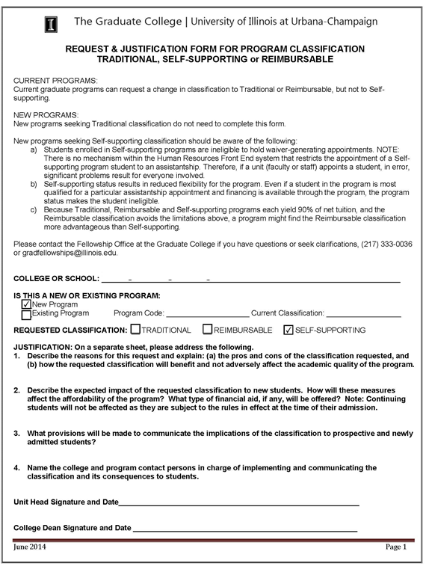

1) Describe the reasons for this request and explain: (a) the pros and cons of the classification requested, and (b) how the requested classification will benefit and not adversely affect the academic quality of the program.

2) Describe the expected impact of the requested classification to new students. How will these measures affect the affordability of the program? What type of financial aid, if any, will be offered? Note: Continuing students will not be affected as they are subject to the rules in effect at the time of their admission.
3) What provisions will be made to communicate the implications of the classification to prospective and newly admitted students?

4) Name the college and program contact persons in charge of implementing and communicating the classification and its consequences to students.

